Cross-sectional radius
# Source: AI Source: Provided by: [Data Path: Persons Table -> ID Column: 1, Name_En Column: Motasem Essam] -> From: [ChatGPT] on [7/25/2026]
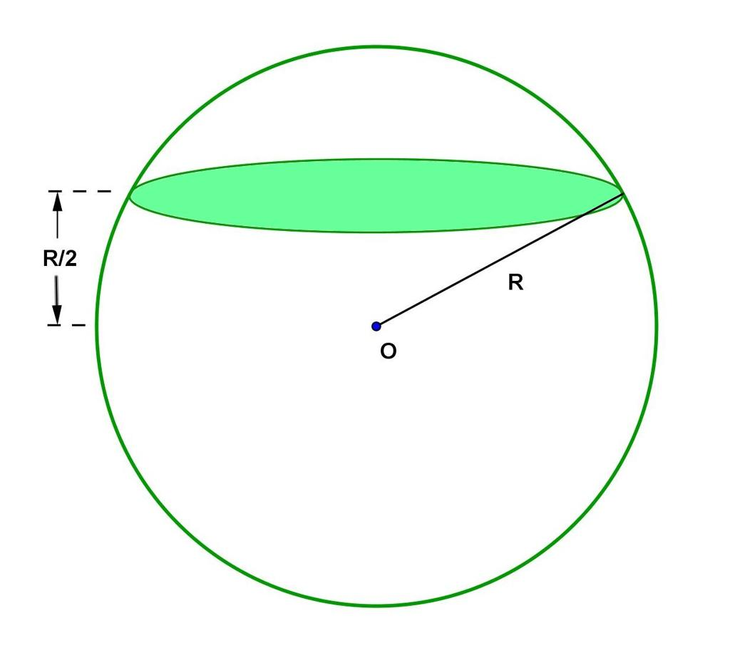
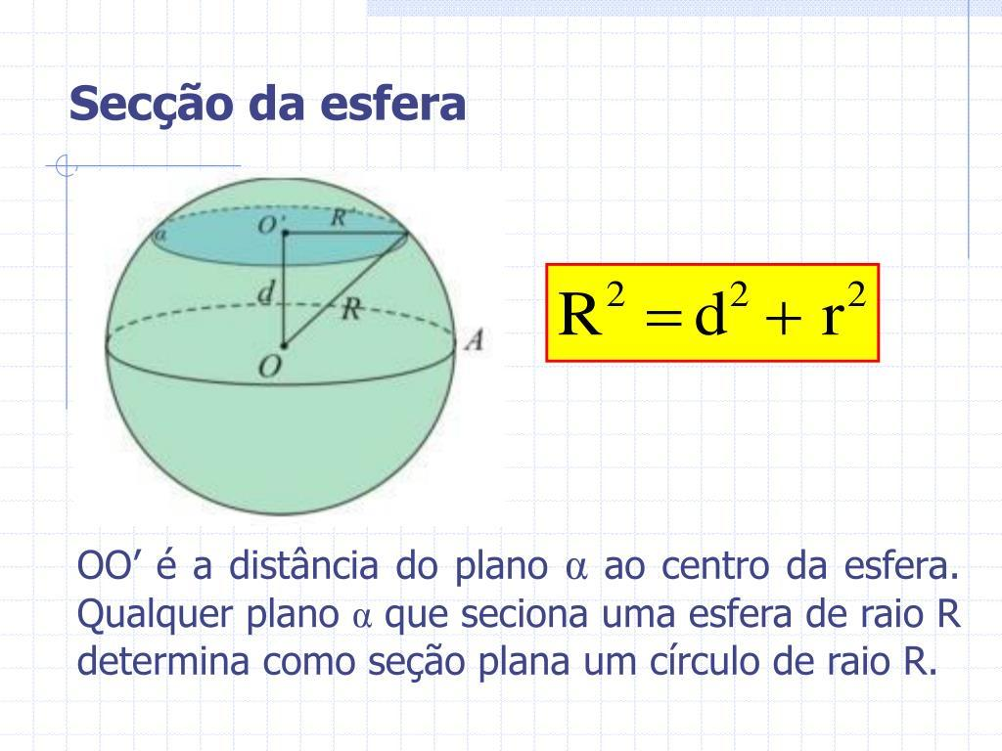
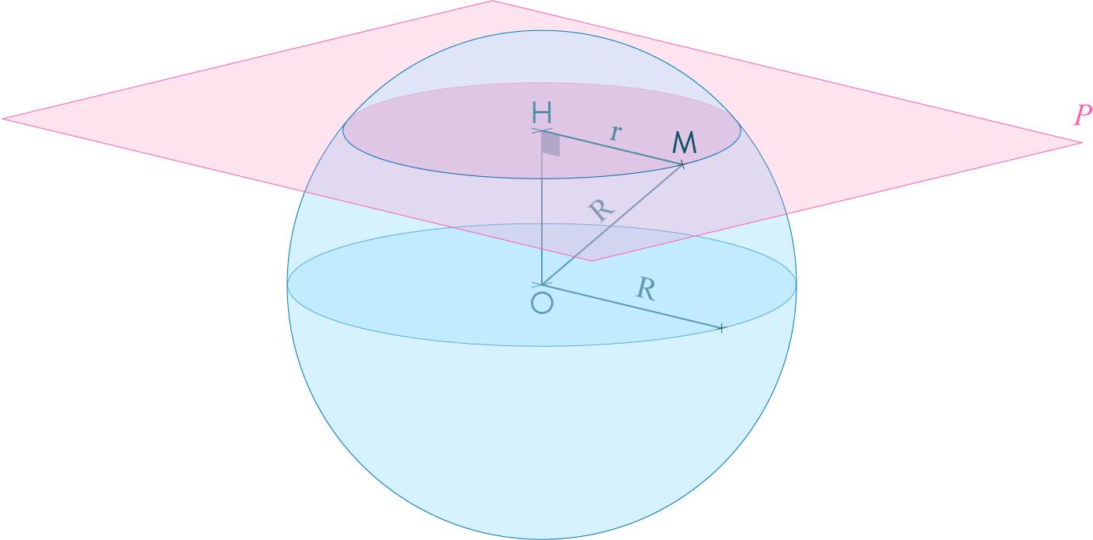

Definition
# Source: AI Source: Provided by: [Data Path: Persons Table -> ID Column: 1, Name_En Column: Motasem Essam] -> From: [ChatGPT] on [7/25/2026]
The cross-sectional radius of a sphere is the radius of the circle formed when a plane intersects the sphere.
The cross-sectional circle may be smaller than the sphere's great circle when the cutting plane does not pass through the sphere's center. If the plane passes through the center, the cross-sectional circle is a great circle, and its radius equals the sphere's radius.

Simple Definition
# Source: AI Source: Provided by: [Data Path: Persons Table -> ID Column: 1, Name_En Column: Motasem Essam] -> From: [ChatGPT] on [7/25/2026]
The cross-sectional radius is the distance from the center of a circular cross-section to any point on its circumference.
- Sphere center: The center of the original sphere.
- Cutting plane: A plane that intersects the sphere.
- Cross-sectional center: The center of the resulting circular section.
- Cross-sectional radius: The distance from the cross-sectional center to its circumference.
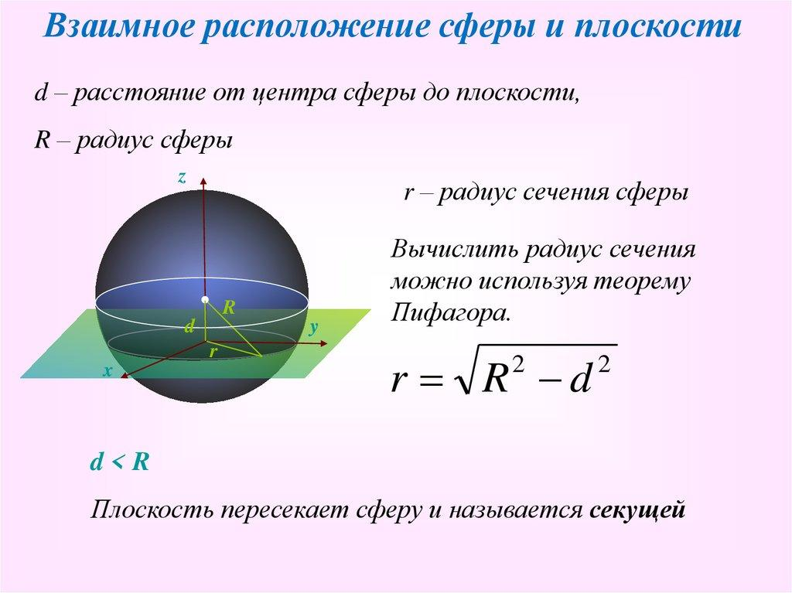

Geometric Representation
# Source: AI Source: Provided by: [Data Path: Persons Table -> ID Column: 1, Name_En Column: Motasem Essam] -> From: [ChatGPT] on [7/25/2026]
Let:
- $O$ be the center of the sphere.
- $R$ be the sphere's radius.
- $C$ be the center of the cross-sectional circle.
- $r$ be the cross-sectional radius.
- $d=OC$ be the perpendicular distance from the sphere's center to the cutting plane.
The cross-sectional radius is $r$, and the sphere radius is $R$.
Because the segment from $O$ to $C$ is perpendicular to the cutting plane, triangle $OCP$ is a right triangle for any point $P$ on the cross-sectional circumference.
Using the Pythagorean theorem:
$$R^{2}=d^{2}+r^{2}$$
Therefore:
$$\boxed{r=\sqrt{R^{2}-d^{2}}}$$
This formula applies when the plane intersects the sphere in a circle and $0≤d<R$.

Types of Spherical Cross-Sections
# Source: AI Source: Provided by: [Data Path: Persons Table -> ID Column: 1, Name_En Column: Motasem Essam] -> From: [ChatGPT] on [7/25/2026]

Central Cross-Section
# Source: AI Source: Provided by: [Data Path: Persons Table -> ID Column: 1, Name_En Column: Motasem Essam] -> From: [ChatGPT] on [7/25/2026]
The cutting plane passes through the sphere's center.
$$d=0, r=R$$
The cross-section is a great circle.
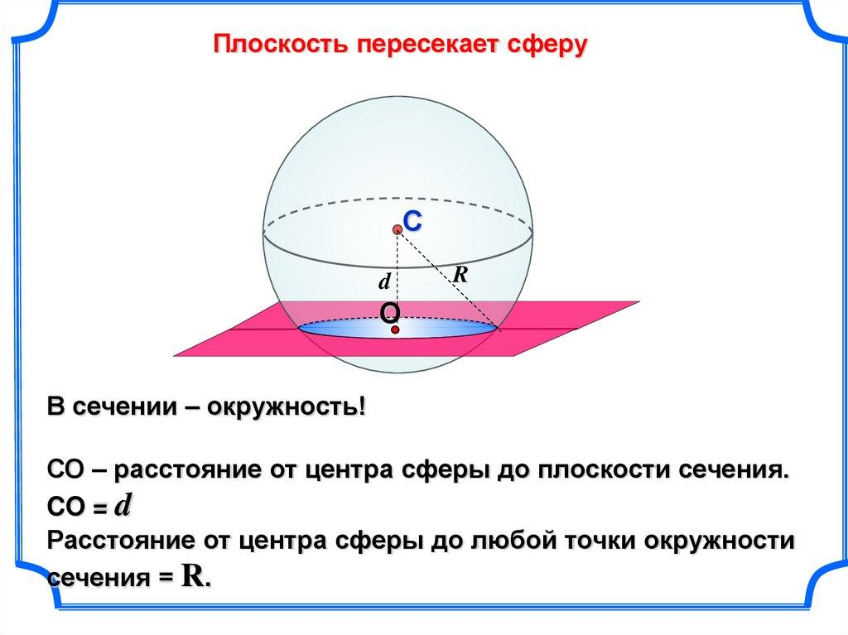

Noncentral Cross-Section
# Source: AI Source: Provided by: [Data Path: Persons Table -> ID Column: 1, Name_En Column: Motasem Essam] -> From: [ChatGPT] on [7/25/2026]
The plane intersects the sphere away from its center.
$$0<d<R, r<R$$
The cross-section is a small circle.
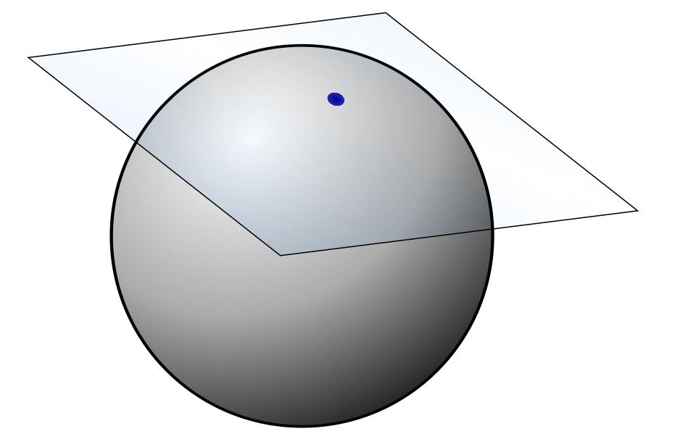

Tangent Plane
# Source: AI Source: Provided by: [Data Path: Persons Table -> ID Column: 1, Name_En Column: Motasem Essam] -> From: [ChatGPT] on [7/25/2026]
The plane touches the sphere at exactly one point.
$$d=R, r=0$$
There is no nonzero-radius cross-sectional circle; the intersection is a single point.

Key Characteristics
# Source: AI Source: Provided by: [Data Path: Persons Table -> ID Column: 1, Name_En Column: Motasem Essam] -> From: [ChatGPT] on [7/25/2026]
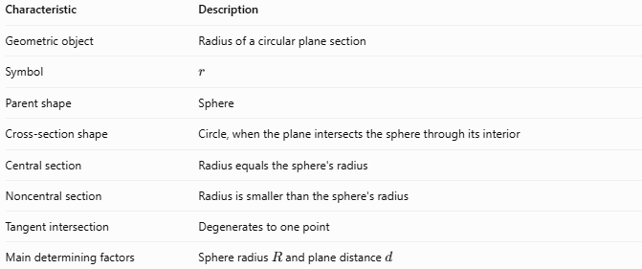
Characteristic | Description
Geometric object | Radius of a circular plane section
Symbol | $$r$$
Parent shape | Sphere
Cross-section shape | Circle, when the plane intersects the sphere through its interior
Central section | Radius equals the sphere's radius
Noncentral section | Radius is smaller than the sphere's radius
Tangent intersection | Degenerates to one point
Main determining factors | Sphere radius $R$ and plane distance $d$

Mathematical Formulas

Cross-Sectional Radius
# Source: AI Source: Provided by: [Data Path: Persons Table -> ID Column: 1, Name_En Column: Motasem Essam] -> From: [ChatGPT] on [7/25/2026]
$$\boxed{r=\sqrt{R^{2}-d^{2}}}$$
where $R$ is the sphere's radius and $d$ is the perpendicular distance from its center to the plane.

Finding the Plane Distance
# Source: AI Source: Provided by: [Data Path: Persons Table -> ID Column: 1, Name_En Column: Motasem Essam] -> From: [ChatGPT] on [7/25/2026]
If the sphere radius and cross-sectional radius are known:
$$\boxed{d=\sqrt{R^{2}-r^{2}}}$$

Cross-Sectional Circumference
# Source: AI Source: Provided by: [Data Path: Persons Table -> ID Column: 1, Name_En Column: Motasem Essam] -> From: [ChatGPT] on [7/25/2026]
The circumference of the circular cross-section is:
$$\boxed{C=2πr}$$

Cross-Sectional Area
# Source: AI Source: Provided by: [Data Path: Persons Table -> ID Column: 1, Name_En Column: Motasem Essam] -> From: [ChatGPT] on [7/25/2026]
The area of the circular cross-section is:
$$\boxed{A=πr^{2}}$$
Substituting the cross-sectional radius formula:
$$\boxed{A=π\left(R^{2}-d^{2}\right)}$$

Special Case: Great Circle
# Source: AI Source: Provided by: [Data Path: Persons Table -> ID Column: 1, Name_En Column: Motasem Essam] -> From: [ChatGPT] on [7/25/2026]
When the cutting plane passes through the center, $d=0$:
$$r=\sqrt{R^{2}}=R$$
Thus, the great circle has the same radius as the sphere.

Worked Examples
# Source: AI Source: Provided by: [Data Path: Persons Table -> ID Column: 1, Name_En Column: Motasem Essam] -> From: [ChatGPT] on [7/25/2026]
Example 1 — Finding the Cross-Sectional Radius
A sphere has a radius of $10\text{ cm}$. A plane cuts the sphere $6\text{ cm}$ from its center. Find the cross-sectional radius.
Solution:
Given:
$$R=10, d=6$$
Apply the formula:
$$r=\sqrt{R^{2}-d^{2}}$$
$$r=\sqrt{{10}^{2}-6^{2}}=\sqrt{100-36}$$
$$\boxed{r=8\text{ cm}}$$
Example 2 — Finding the Cross-Sectional Area
A sphere has a radius of $13\text{ m}$, and a cutting plane is $5\text{ m}$ from its center. Find the area of the cross-section.
Solution:
First, calculate the cross-sectional radius:
$$r=\sqrt{{13}^{2}-5^{2}}=\sqrt{169-25}=\sqrt{144}=12\text{ m}$$
Then calculate the area:
$$A=πr^{2}$$
$$A=π{\left(12\right)}^{2}$$
$$\boxed{A=144π{\text{ m}}^{2}}$$
Approximately:
$$A≈452.39{\text{ m}}^{2}$$
Example 3 — Finding the Plane's Distance
A sphere has a radius of $15\text{ cm}$, and its circular cross-section has a radius of $9\text{ cm}$. Find the distance between the sphere's center and the cutting plane.
Solution:
$$d=\sqrt{R^{2}-r^{2}}$$
$$d=\sqrt{{15}^{2}-9^{2}}=\sqrt{225-81}$$
$$d=\sqrt{144}$$
$$\boxed{d=12\text{ cm}}$$

Cross-Sectional Radius vs. Sphere Radius
# Source: AI Source: Provided by: [Data Path: Persons Table -> ID Column: 1, Name_En Column: Motasem Essam] -> From: [ChatGPT] on [7/25/2026]
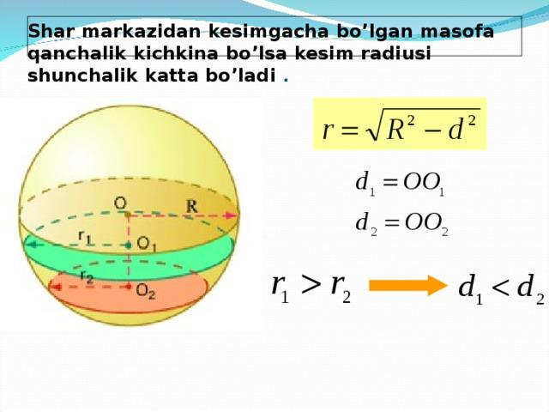
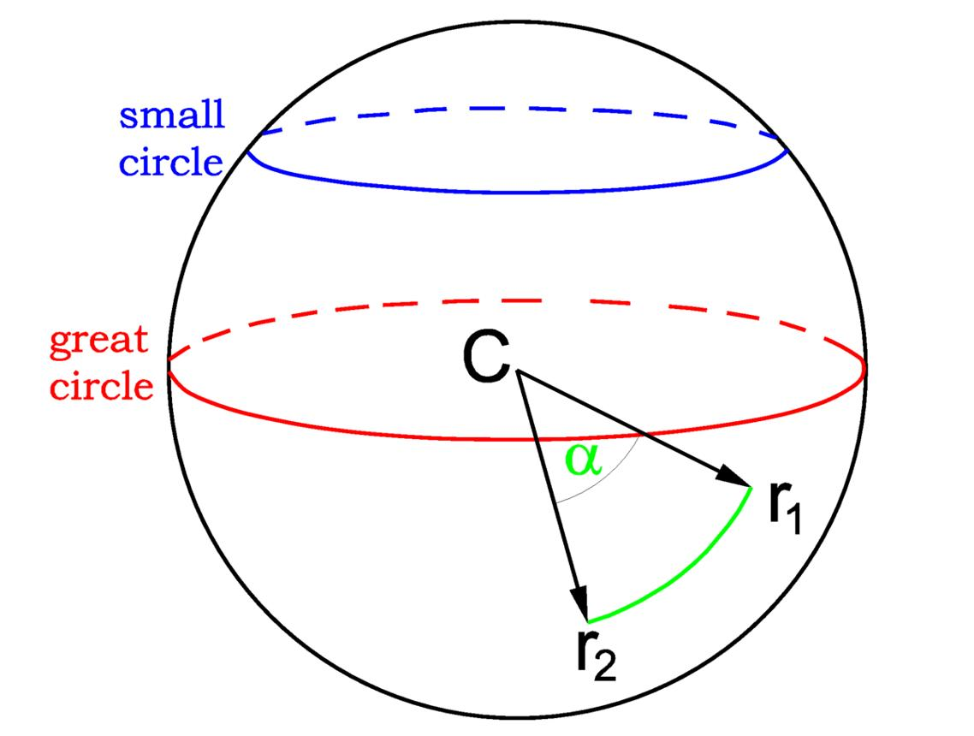
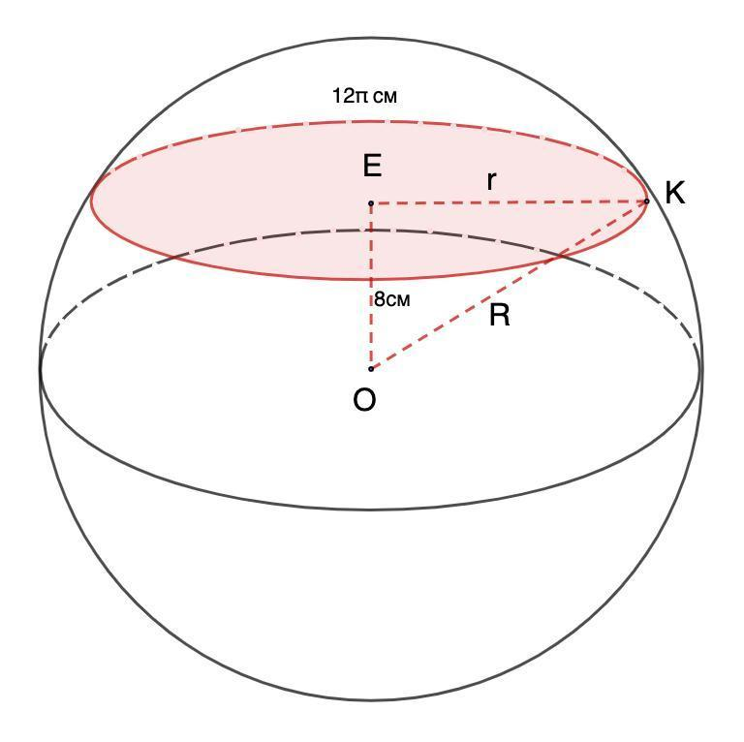
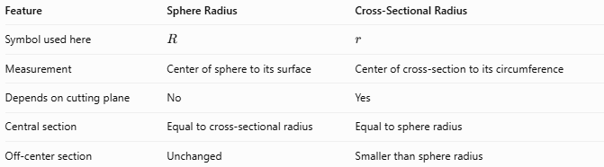
Feature | Sphere Radius | Cross-Sectional Radius
Symbol used here | $$R$$ | $$r$$
Measurement | Center of sphere to its surface | Center of cross-section to its circumference
Depends on cutting plane | No | Yes
Central section | Equal to cross-sectional radius | Equal to sphere radius
Off-center section | Unchanged | Smaller than sphere radius

Applications
# Source: AI Source: Provided by: [Data Path: Persons Table -> ID Column: 1, Name_En Column: Motasem Essam] -> From: [ChatGPT] on [7/25/2026]
Cross-sectional radius is useful in:
- Engineering: Measuring circular cuts through spherical components.
- Manufacturing: Designing spherical tanks, balls, and rounded parts.
- Geometry: Calculating the size of circular intersections.
- Medical imaging: Understanding circular slices through approximately spherical structures.
- Computer graphics: Computing intersections between spheres and planes.

Key Points
# Source: AI Source: Provided by: [Data Path: Persons Table -> ID Column: 1, Name_En Column: Motasem Essam] -> From: [ChatGPT] on [7/25/2026]
- A plane intersecting a sphere through its interior creates a circular cross-section.
- The cross-sectional radius depends on the sphere radius and the plane's distance from the center.
- The formula is $r=\sqrt{R^{2}-d^{2}}$.
- A central cross-section is a great circle with radius $R$.
- An off-center cross-section is a smaller circle with radius $r<R$.
- A tangent plane touches the sphere at a single point, not a circle of positive radius.

Conclusion
# Source: AI Source: Provided by: [Data Path: Persons Table -> ID Column: 1, Name_En Column: Motasem Essam] -> From: [ChatGPT] on [7/25/2026]
The cross-sectional radius measures the radius of a circle formed by cutting a sphere with a plane. Its size depends on how far the plane is from the sphere's center: the central section is the largest, and the radius decreases as the plane moves toward the surface.

